PAST RMT PIN ORDER FORM NORTH ATLANTIC REGION ONE
Sweet Adelines International
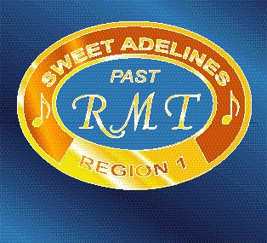
78 Stowell Rd.
Bedford NH 03110
email: finance@sai-region1.org

Billing Address: Ship To: (if not the same as Bill To address)

__________________________________ _____________________________________
__________________________________ _____________________________________
__________________________________ _____________________________________
__________________________________ _____________________________________
Phone: __________________________ Cell: ______________________________
email: ___________________________________________________________________
Pins may be ordered as either Stick Pins (long post) or Tackettes (small post).
$25 each for fewer than 10; $21 each for 10 or more
Engraving Stick or Qty
Region # Tackette (Min 5) Total ($)
__________ __________ __________ $____ each $______________

Shipping/Handling (Continental US Only) (*) $ _____16.00____
(*) S&H to locations outside the Continental US may vary
S&H for an additional 5 pins, add $8.00 for shipping $______________

TOTAL $______________
Payments may be made by check only payable to North Atlantic Region One (in US $$ if you are ordering from outside the U.S.A). Please send order form and payment to:

Lauren O’Sullivan
FC, Region 1
78 Stowell Rd
Bedford, NH 03110

